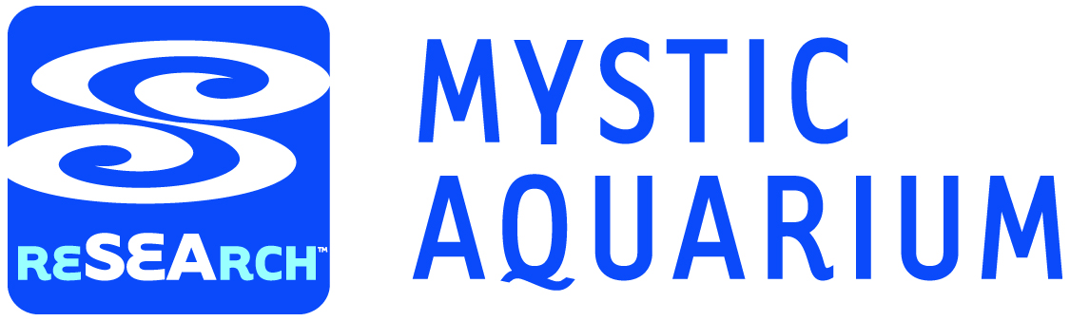
Aquarium “Oops”
A Near-Miss Report Form

What is a Near Miss?
A near miss is an unplanned event that did not result in injury, illness, or damage. However, the event had the potential to do so.
Example: An employee needs to use a step ladder to accomplish a task. Instead of taking the time to retrieve a step ladder he uses a large drum, hefts himself up on this, stands, and the drum twists out from under him. He lands on his feet with no injury. This action is a Near Miss in that he tried completing a task in an unsafe manner and injuries, possibly severe, could have occurred.
You may hear Near Misses referred to in other ways: close call, near collision, near hit, or simply, “Wow, that was close”. Here at Mystic Aquarium, we call them an Aquarium “Oops”. We have expanded the definition for near miss to include security concerns. If you feel we are at risk and see a way to improve our security please note this and pass it along.
Why Report Near Misses?
When reporting an Aquarium Near Miss your name will be held in confidence and you will not be penalized in any way. Including your name will help us follow-up more effectively, but is optional. The goal is not to assign blame to a particular individual, only to correct deficiencies and make improvements in our program. Remember, we cannot fix what we do not know. The information you share is valuable and will significantly help Mystic Aquarium become a safer workplace.
If you think that an event had the potential to negatively impact a guest’s experience, an animal’s welfare, the health and safety of our staff or guests, or to harm the environment or our physical property, we want to know about it!
How to Complete the Form
Please complete the form, attach any additional pertinent information such as pictures, drawings, SDSs etc. After you complete the form, please put in a sealed inter-office envelope addressed to the safety team.

Thanks for taking the time to help make Mystic Aquarium a safer and more secure workplace!

Aquarium “Oops”
A Near-Miss Report Form

Please forward completed form to Safety & Security
Check appropriate level
RED – Stop Work and Report  □ |  | YELLOW – Use Caution and Report  □ |  | GREEN – Continue and Report  □
Location/department: |  | Date: |  | Time:
Public area (Y/N): |  | Reported by (Optional): |  | Supervisor review (Optional):
Ground surface and weather conditions (If applicable): |  |  |  | Date of supervisor review:
Category of near miss (Circle all which apply): Potential to negatively impact the guest experience
Potential injury to person(s) Potential injury to animal collection
Potential security issue Potential property damage Potential environmental incident
Description of occurrence (Use reverse if necessary):
Were photos taken? |  |  | Were photos sent to Safety & Security?
Yes □ | No □ |  | Yes □ |  | Date:

Corrective actions taken:

Safety & Security Review
Root causes (Required for red):
Name: | Date: | Residual risk at acceptable level?  Yes □ No □

