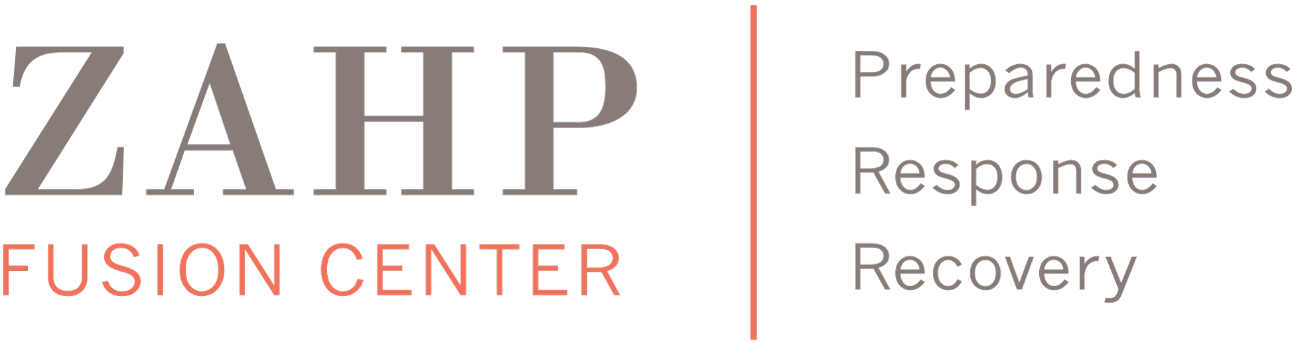

Statement of Organizational Support

One copy of this statement must be electronically signed by the organizational CEO/Director or equivalent using the checkbox below, and submitted as an attachment to the ZAHP Grant Application email titled “SIS Organization Name” for each facility or organization listed as a collaborator.

By signing this form, all participating organizations, whether participating as a facility or through an employee, take responsibility for completing their part of the proposed project.

All Statement of Organizational Support forms must be received as part of the ZAHP Grant Application Email.

The (Organization Name) Click here to enter text has reviewed the proposal titled (Project Title) Click here to enter text and commits itself to providing the time, resources and/or financial support as stated in the application.

Click here to enter text.
Name

Click here to enter text.
Title

Click here to enter text.
Date

☐ Checking this box serves as my electronic signature to this letter of support. I affirm that I am the person listed above and understand that this letter WILL NOT be accepted unless this box is checked.

