Internet Functional Exercise
Internet Functional Exercise

Situation Manual
07/13-15/2015

This Situation Manual (SitMan) provides exercise participants with all the necessary tools for their roles in the exercise. Some exercise material is intended for the exclusive use of exercise planners, facilitators, and evaluators, but players may view other materials that are necessary to their performance. All exercise participants may view the SitMan.

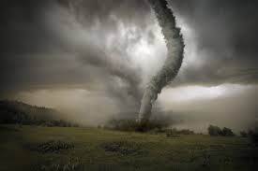

Exercise Overview
Exercise Name | Zoo Ready 15 Internet Functional Exercise
Exercise Dates | 07/13-15/2015
Scope | This exercise is an internet based functional exercise, planned for 07/13-15/2015. Exercise play is limited to pre-selected zoological institutions and partner regulatory agencies.
Mission Area(s) | Response & Recovery
Core Capabilities | Situational Assessment  Operational Communication  Operational Coordination  On-Scene Security & Protection
Objectives | Demonstrate the facility’s ability to prepare for natural hazards  Demonstrate the communication system within their facility  Demonstrate the facility’s ability to communicate with first responders  Demonstrate the facility’s ability to work with the Incident Command System  Demonstrate the ability for facility personnel to work with established Emergency Operation Plans for their facility.  Demonstrate the facility’s ability to deal with long term consequences after a disaster.
Threat or Hazard | Natural Hazard
Scenario | A scenario has been developed that will require Illinois Zoological Parks and partner regulatory agencies to simulate response to a tornado scenario.
Sponsor | University of Illinois, College of Veterinary Medicine, Center for One Health Illinois
Participating Organizations | Invited zoological institutions and partner regulatory agencies.
Point of Contact | Exercise Director: Yvette Johnson Walker DVM, MS, PhD: Clinical Epidemiologist, University of Illinois College of Veterinary Medicine, Center for One Health Illinois. University of IL at Urbana-Champaign  1008 West Hazelwood Drive M/C 004 - 227 LAC  Urbana, Illinois, 61802  217-333-1903  yjjohn38@illinois.edu

General Information

Exercise Objectives and Core Capabilities
The following exercise objectives in Table 1 describe the expected outcomes for the exercise. The objectives are linked to core capabilities, which are distinct critical elements necessary to achieve the specific mission area(s). The objectives and aligned core capabilities are guided by elected and appointed officials and selected by the Exercise Planning Team.
Table 1. Exercise Objectives and Associated Core Capabilities
Exercise Objective | Core Capability
Demonstrate the facility’s ability to prepare for natural hazards | Situational Assessment
Demonstrate the communication system within their facility | Operational Communication
Demonstrate the facility’s ability to communicate with first responders | Operational Coordination
Demonstrate the facility’s ability to work with the Incident Command System | On-Scene Security & Protection
Demonstrate the ability for facility personnel to work with established Emergency Operation Plans for their facility. | Operational Coordination, Situational Assessment
Demonstrate the facility’s ability to deal with long term consequences after a disaster. | Operational Coordination, On-Scene Security & Protection

Participant Roles and Responsibilities
The term participant encompasses many groups of people, not just those playing in the exercise. Groups of participants involved in the exercise, and their respective roles and responsibilities, are as follows:
- Players. Players are personnel who have an active role in discussing or performing their regular roles and responsibilities during the exercise. Players discuss or initiate actions in response to the simulated emergency.
- Observers. Observers do not directly participate in the exercise. However, they may support the development of player responses to the situation during the discussion by asking relevant questions or providing subject matter expertise.
- Facilitators. Facilitators provide situation updates and moderate discussions. They also provide additional information or resolve questions as required. Key Exercise Planning Team members also may assist with facilitation as subject matter experts (SMEs) during the exercise.
- Evaluators. Evaluators are assigned to observe and document certain objectives during the exercise. Their primary role is to document player discussions, including how and if those discussions conform to plans, polices, and procedures.

Exercise Structure
This exercise will be a multimedia, facilitated exercise. Players will participate in the following five modules:
- Module 1: Severe Weather Preparedness
- Module 2: Initial Incident
- Module 3: Initial Response
- Module 4: Response
- Module 5: Recovery

Each module begins with a multimedia update that summarizes key events occurring within that time period. After the updates, participants review the situation and engage in functional group discussions of appropriate response/recovery issues. For this exercise, the functional groups are the as follows:
- IL State Veterinarian
- Brookfield Zoo
- Cosley Zoo
- Henson Robinson Zoo
- Lincoln Park Zoo
- Miller Park Zoo
- Peoria Zoo
- Knoxville Zoo (TN)
- Scovill Zoo

After these functional group discussions, participants will engage in a moderated plenary discussion in which a spokesperson from each group will present a synopsis of the group’s actions, based on the scenario.

Exercise Guidelines
- This exercise will be held in an open, low-stress, no-fault environment. Varying viewpoints, even disagreements, are expected.
- Respond to the scenario using your knowledge of current plans and capabilities (i.e., you may use only existing assets) and insights derived from your training.
- Decisions are not precedent setting and may not reflect your organization’s final position on a given issue. This exercise is an opportunity to discuss and present multiple options and possible solutions.
- Issue identification is not as valuable as suggestions and recommended actions that could improve response/recovery efforts. Problem-solving efforts should be the focus.

Exercise Assumptions and Artificialities
In any exercise, assumptions and artificialities may be necessary to complete play in the time allotted and/or account for logistical limitations. Exercise participants should accept that assumptions and artificialities are inherent in any exercise, and should not allow these considerations to negatively impact their participation. During this exercise, the following apply:
- The exercise is conducted in a no-fault learning environment wherein capabilities, plans, systems, and processes will be evaluated.
- The exercise scenario is plausible, and events occur as they are presented.
- All players receive information at the same time.

Exercise Evaluation
Evaluation of the exercise is based on the exercise objectives and aligned capabilities, capability targets, and critical tasks, which are documented in Exercise Evaluation Guides (EEGs). Evaluators have EEGs for each of their assigned areas. Additionally, players will be asked to complete participant feedback forms. These documents, coupled with facilitator observations and notes, will be used to evaluate the exercise and compile the After-Action Report (AAR).

Module 1: SEVERE WEATHER PREPAREDNESS

July 13th, 2015: Morning
The area has been under a tornado watch since 1315 hours. Since that time a large storm system moving through and it is approximately 20 miles from your facility moving at 40 miles per hours.
The gusting winds, heavy rain and hail accompanying the storm have put local emergency services on the alert for further developments. The weather spotter network has been activated. The local Emergency Managers have been advised of the situation and have asked the emergency services heads to assemble at the local EOC.
Staff is notified by zoo personnel that the storm has been upgraded to a Warning. The projected path of the tornado has it passing through your facility. NWS and weather spotters have reported a tornado approaching the area.

Key Issues

- A tornado watch has been upgraded to a warning for the area
- Your facility is in the projected path
- Weather spotters have confirmed a tornado on the ground.

Questions
Based on the information provided, participate in the discussion concerning the issues raised in Module 1. Identify any critical issues, decisions, requirements, or questions that should be addressed at this time.
The following questions are provided as suggested subjects that you may wish to address as the discussion progresses. These questions are not meant to constitute a definitive list of concerns to be addressed, nor is there a requirement to address every question.

Exercise Participants
- Who is the Incident Commander at the facility at this point?
- How is he/she selected?
- How is he/she notified that they are the IC?
- How is the IC updated on potential weather emergencies/ other emergencies?
- What is your notification system? For zoo personnel/contractors? For zoo guests?
- Does your facility have designated storm shelters on grounds? Are guests moved to those locations at this time?
- What is the capacity of your shelter-in-place areas?
- What is Plan B if capacity is exceeded?
- Is the shelter-in-place area handicapped accessible?
- What supplies do you have in the designated shelter-in-place areas?
- How long can people be maintained in the shelter-in-place location?
- Who is in charge in the different shelter-in-place areas?

Module 2: INITIAL INCIDENT

July 13th, 2015: Afternoon
At approximately 1335 hours, police patrol reports that the tornado has struck a portion of the area leaving a path of destruction 440 yards wide and a mile long. The path of destruction covers a very large part of the city. The zoo has missed the direct patch of the tornado but was caught in the debris patch.

Key Issues
- A tornado has struck the area
- Damage has occurred
- Facility needs to evaluate their response

Questions
Based on the information provided, participate in the discussion concerning the issues raised in Module 2. Identify any critical issues, decisions, requirements, or questions that should be addressed at this time.
The following questions are provided as suggested subjects that you may wish to address as the discussion progresses. These questions are not meant to constitute a definitive list of concerns to be addressed, nor is there a requirement to address every question.

Exercise Participants
- Who is the Incident Commander at the facility at this point? How is he/she selected?
- How is he/she notified that they are the IC?
- How is the IC updated on potential weather emergencies/ other emergencies?
- What is your notification/communication system at this time? For zoo personnel/contractors? For zoo guests
- How do you know when it is safe to leave the shelter? Who makes the determination?
- What are some of the hazards that could be faced by guests and staff emerging from shelters at this time?
- How is the information about immediate safety concerns communicated to the different locations?
- What criteria must be met before it is deemed safe to leave the shelter?
- What sort of information should be shared with guests in your shelters at this time?

Module 3: INITIAL RESPONSE

July 14th, 2015: Morning

Based upon radio broadcasts and zoo observers, it is clear that the storm has passed. Zoo staff is just beginning to emerge from the storm shelters, and at first report, it appears that a part of the zoo has sustained major damage. (Please see the map that we have provided for the buildings that have been impacted by the storm.) It is clear that this is an incident that will involve a lot of coordination for an effective, safe response. As you consider the answers to the following questions, keep in mind that we are requesting your answers based upon what you would do within the first several hours after the storm has passed.

Key Issues
- Major damage to their facility
- Determine which issues to react to first
- How are they going to communicate

Questions
Based on the information provided, participate in the discussion concerning the issues raised in Module 3. Identify any critical issues, decisions, requirements, or questions that should be addressed at this time.
The following questions are provided as suggested subjects that you may wish to address as the discussion progresses. These questions are not meant to constitute a definitive list of concerns to be addressed, nor is there a requirement to address every question.

Exercise Participants
- Who is the Incident Commander at the facility at this point? Has it changed?
- What other Command Staff positions do you feel should be filled at this time? (Remember: the Command Staff positions include Liaison Officer, Public Information Officer, and Safety Officer?
- Do you fill the General Staff positions at this time? In your facility, who might that be? (Remember, General Staff positions include Operations, Finance, Logistics and Planning Section Chiefs)
- What sort of information is your facility providing to the following:
- With guests, staff, first responders, emergency management personnel, media, family of guests and staff.
- Your staff: who is responsible for accounting for staff?
- Your guests: Who is on grounds and where are they? Who is responsible for guest safety at this time?
- Who is responsible for assessing and accounting for animals at this time?

Module 4: RESPONSE

July 14th, 2015: Afternoon
It is now approximately 2 hours after the storm has passed. The path of destruction covers a very large part of the city. There is an unconfirmed report that a large number of homes have been destroyed and numerous people trapped in the debris. People and “walking wounded” not trapped by are wandering around the debris field. On-scene police units report they have no access into the damaged area due to large pieces of debris.
Fortunately, original assessment of your facility has revealed a lot of infrastructure damage, but no animal injuries or fatalities! Due to the extreme damage to the area all power is out to the zoo. Numerous gas lines in the area have been damaged and there is a very good chance that gas will be soon turned off by the utility company to prevent any further incidents.
Due to the extent of the damage outside your facility, all emergency personnel are reacting to situations in the residential areas. One of the local hospitals has also been hit by the tornado and all resources are reacting to these areas. First responders are unable to assist you.
Family members of the zoo patrons and staff are beginning to arrive at the zoo and are becoming increasingly concerned about family members in the zoo and want information and access to the zoo property. They are demanding to get into the area.

Key Issues
- Large amount of debris is in and around the facility
- First responders are unable to respond to the needs of the facility
- Family of staff members are wanting into the facility to check on family members

Questions
Based on the information provided, participate in the discussion concerning the issues raised in Module 3. Identify any critical issues, decisions, requirements, or questions that should be addressed at this time.
The following questions are provided as suggested subjects that you may wish to address as the discussion progresses. These questions are not meant to constitute a definitive list of concerns to be addressed, nor is there a requirement to address every question.

Exercise Participants
- Phone lines are down and cell phones are only receiving busy signals. How could you contact outside agencies for assistance?
- Your facility may be without power and natural gas at least for the foreseeable future. What resources do you need? Who would you contact to request those resources? What is Plan B if your usual source is unable to provide the resources requested?
- Given the area of damage that your zoo sustained, can you temporarily move those animals in that area to more secure holding elsewhere in your facility?
- If you assessed your buildings and recognized that you would need to move animals off site for more secure holding until repairs could be made, briefly….does your facility’s contingency plan include where these animals could be moved to?
- What resources can you provide to assist the community? How will you notify local emergency managers that you have resources to contribute?

Module 5: Recovery

July 15th, 2015: Morning
It is now 48 hours after the incident. The damage has been assessed and you are attempting to bring the zoo back to condition to open. However, it is apparent that this is going to be a long-term event and could take several days before utilities can be restored. On-site staff has either left the facility to check on issues at their home or have been allowed to leave by the zoo director.
News media is demanding to be allowed to film the incident.
Zoo staff who remained at the facility has been working for many hours without rest. They are requesting to know when they are going to be relieved.
Radio stations in the area have broadcast that people in the area need help. This has caused a large amount of people “self dispatching” to the area. Emergency responders are asking for guidance on how to handle them.
Zoo staff is still very involved with their homes and families that were part of the tornado’s destruction. An attempt to get staff into the facility to begin clean up is not going well.

Key Issues
- The facility is going to have to be self-sustaining for several days.
- The local media is becoming an issue.
- Spontaneous volunteers are starting to show up at the facility.

Questions
Based on the information provided, participate in the discussion concerning the issues raised in Module 3. Identify any critical issues, decisions, requirements, or questions that should be addressed at this time.
The following questions are provided as suggested subjects that you may wish to address as the discussion progresses. These questions are not meant to constitute a definitive list of concerns to be addressed, nor is there a requirement to address every question.

Exercise Participants
- How long can your institution function without power from the grid? Do you have an alternative power source? Where can you get one in an emergency? What facilities have priority for power restoration? How much fuel do you have stored at your facility? Do you have a source for additional fuel in an emergency?
- How long can your institution function without potable municipal water? What is your plan for providing water to staff, volunteers, and collection animals in the absence of potable municipal water?
- What is the minimum number of staff (and what job titles) do you need to maintain animal care and personnel safety at your facility?
- Who will manage personnel and personnel issues for facility staff?
- Who will manage and coordinate volunteer support?
- Who is managing messaging to the media?
- Who is managing security for the facility? If your security resources are overwhelmed, how do you obtain additional assistance? Looting is a potential problem.

Appendix A: Exercise Schedule
Time | Activity
July 13th 2015
0800 | Module 1: Severe Weather Preparedness
1300 | Module 2: Initial Incident
July 14th 2015
0800 | Module 3: Initial Response
1300 | Module 4: Response
July 15th 2015
0800 | Module 5: Recovery
1300 | Hot Wash
July 20th 2015
1000 | After Action Conference

Appendix B: Exercise Participants
Participating Organizations
Federal
USDA APHIS AC
Association of Zoos and Aquariums
State
IL State Veterinarian
University of Illinois Urban Campus
Zoos
Cosley Zoo

Scovill Zoo
Henson Robinson Zoo
Miller Park Zoo
Brookfield Zoo
Peoria Zoo
Lincoln Park Zoo
Knoxville Zoo (Tennessee)

Appendix C: Exercise Site Maps

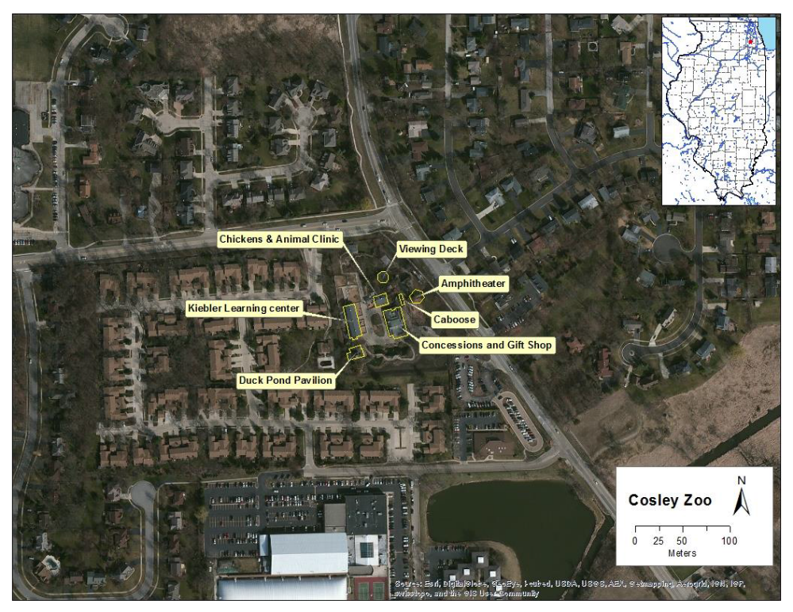
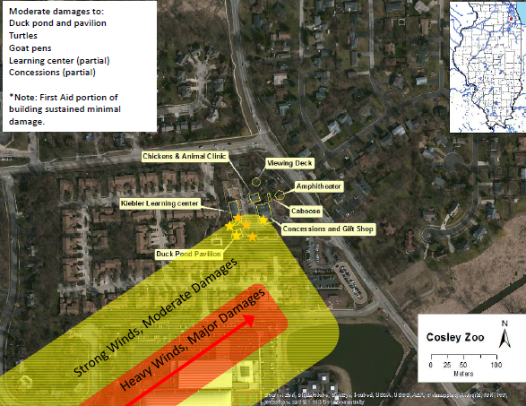
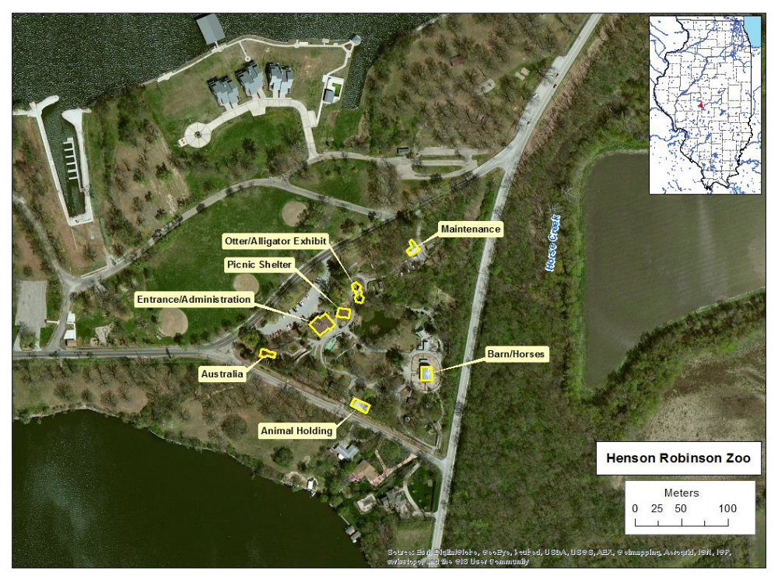

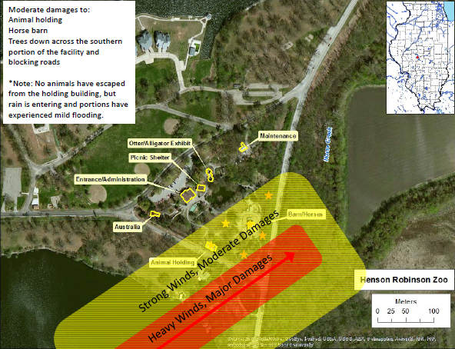
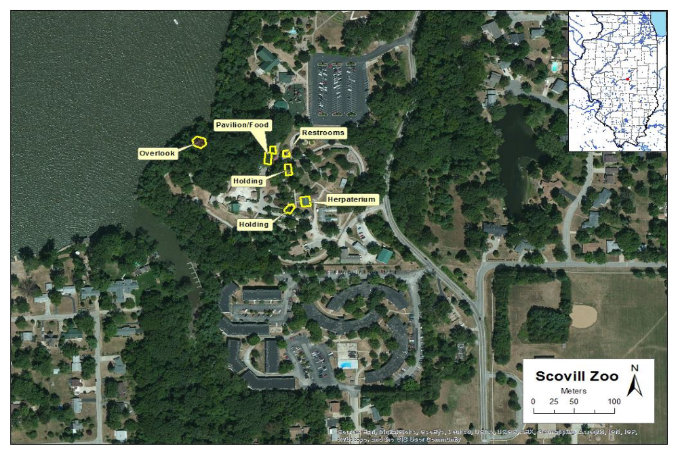

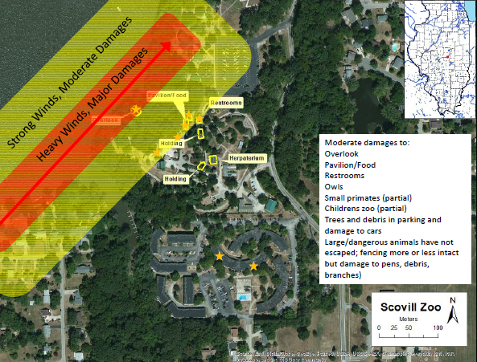
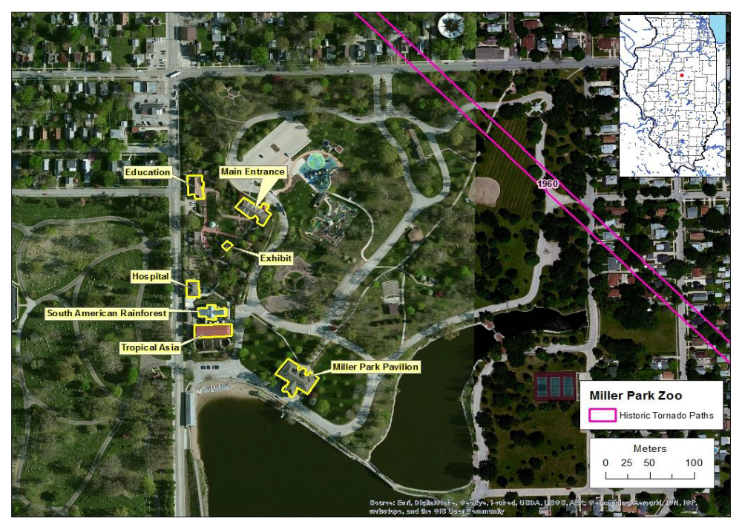

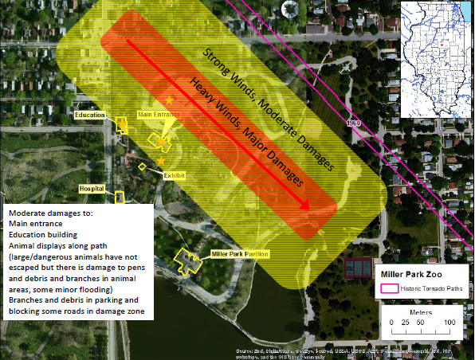
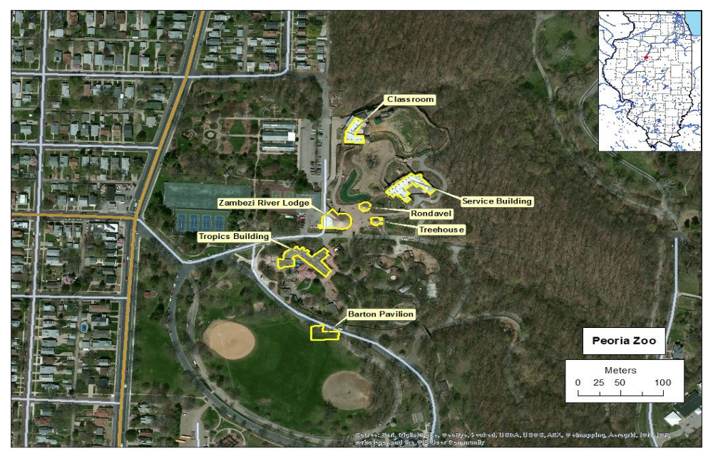

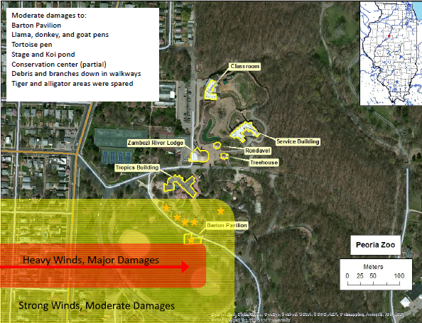

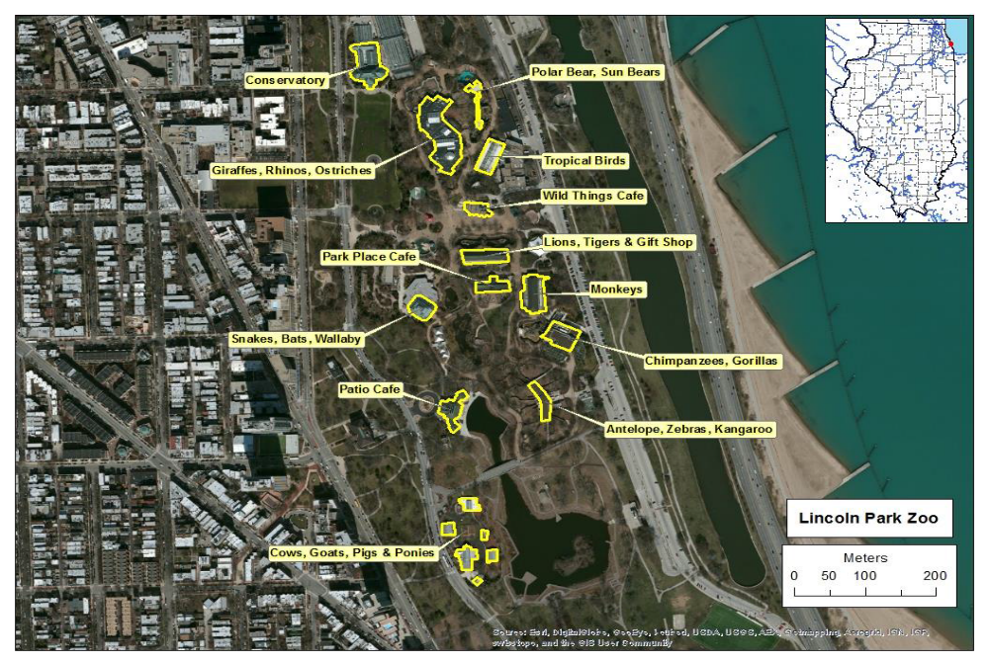

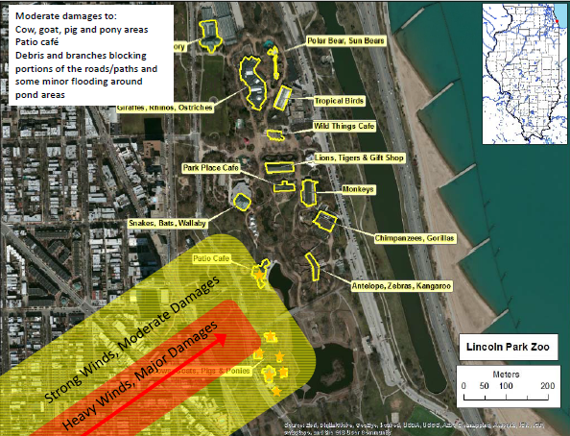
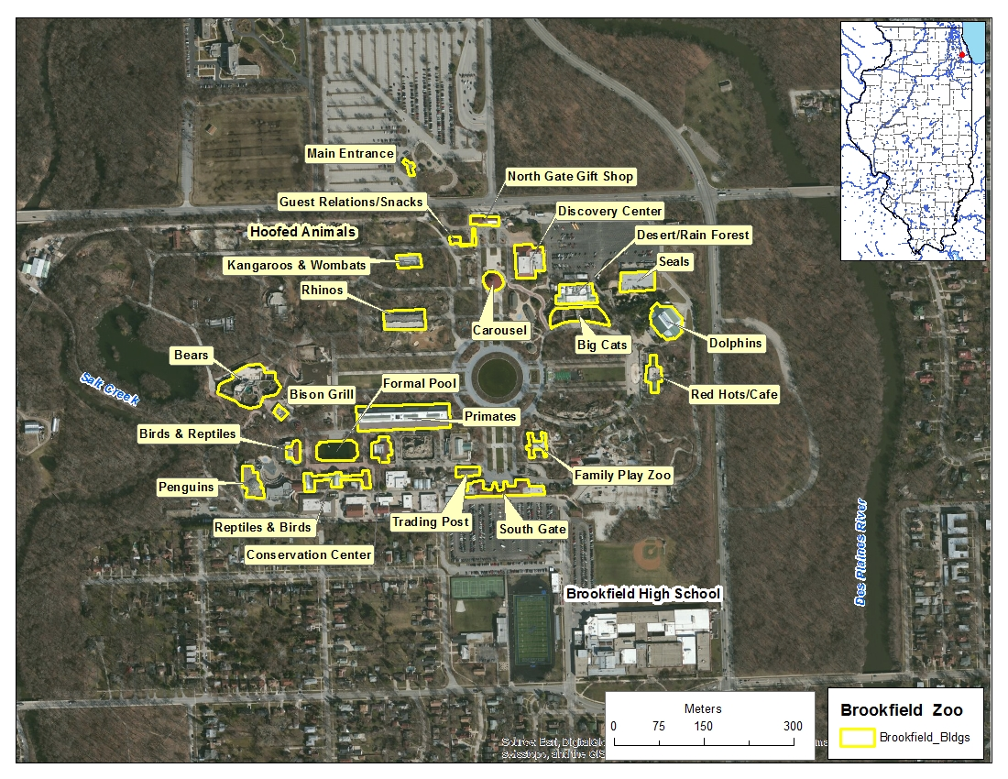

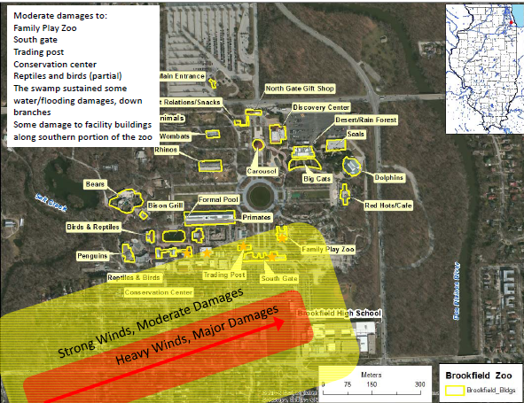
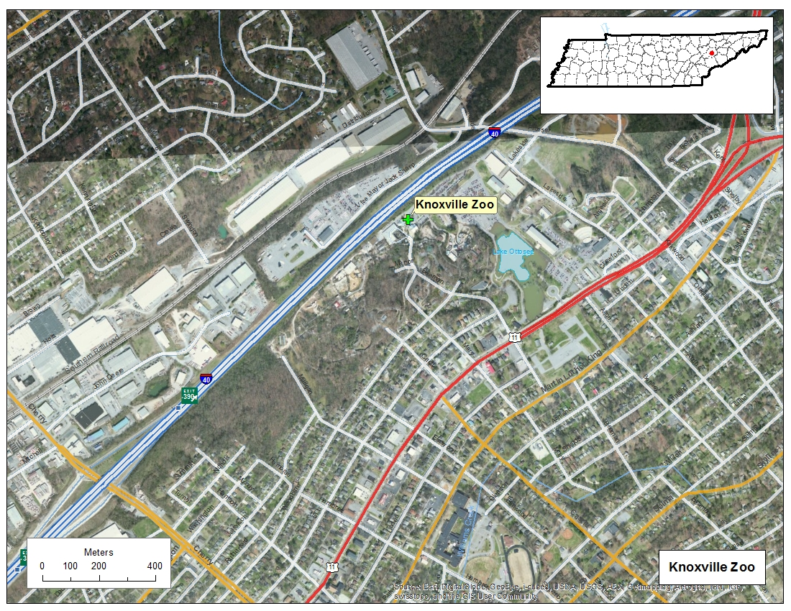

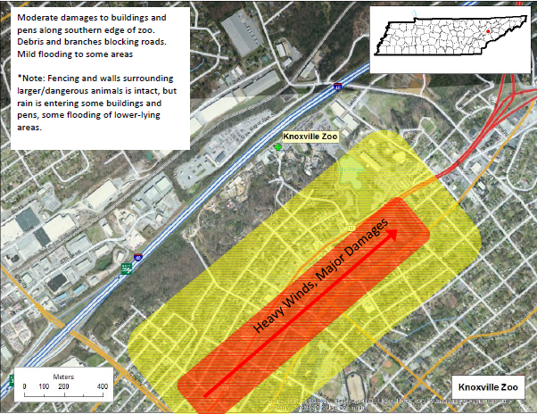

Appendix D: Acronyms
Acronym | Term
AZA | Association of Zoos and Aquariums
DHS | U.S. Department of Homeland Security
EOC | Emergency Operations Center
HSEEP | Homeland Security Exercise and Evaluation Program
IC | Incident Commander
NWS | National Weather Service
SitMan | Situation Manual
SME | Subject Matter Expert
TTX | Tabletop Exercise
USDA APHIS AC | United States Department of Agriculture, Animal and Plant Health Inspection Service, Animal Care

